**Power Engineering 2 – Electrical Machines Seminar 2**

**9th November 2022**

**Seminar Student Sheet**

**Part 1:** A shunt excited DC motor has an armature resistance, RA = 0.5Ω and it is supplied by 240V. Under no-load operation, the armature current, IA = 2A, the field current IF = 1.2A and the speed, N = 1500rpm.

a) If the voltage supply is fixed and the armature current changes to 40A, calculate the new speed. (Ans – 1380 rpm)

b) Calculate the efficiency and the mechanical torque. (Ans – 89%, T=60.89 Nm)

**Part 2:** A 250V PM dc machine has an armature resistance of 0.15Ω. It is permanently coupled to a constant torque load, of such a magnitude that the motor takes 120 A from the supply when running at a rated speed of 600 rpm. Under normal operation switch S1 is closed, S2 & S3 are open, figure 1(a).

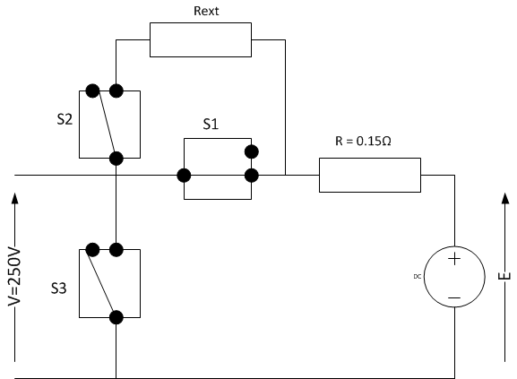

Figure 1(a) – normal operation

Calculate the following:

1. With constant torque load calculate the induced emf. (Ans – 232V)
2. Calculate the machine constant (KE = KT). (Ans – 3.69 Nm/A)
3. Calculate the constant load torque. (Ans – Tload = 443 Nm)

Emergency braking is required for the application in which the machine must come to a standstill in 0.5s. During emergency braking, the supply voltage is removed, the constant load torque is still coupled to the machine, S1 is opened, S2 & S3 are closed so that an additional resistance, Rext, is switched into the circuit in series with R, as shown in Figure 1(b) to limit the braking current to 240A.

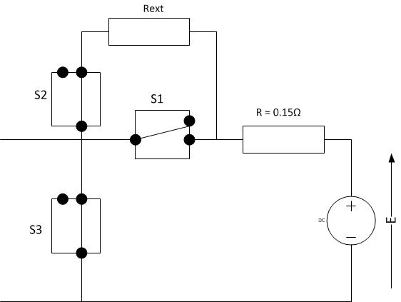

Figure 1(b) – emergency braking

1. Under the emergency braking condition calculate the external resistance, Rext, to limit the current to 240A. (Ans – Rext = 0.817Ω)